BANK LOAN REPORT QUERY DOCUMENT
KPI’S :
Total Loan Applications :
SELECT
COUNT(id) AS total_loan_applications
FROM
bank_loan_data
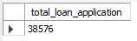

MTD Loan Application :
SELECT
COUNT(id) AS MTD_total_loan_applications
FROM
bank_loan_data
WHERE
MONTH(issue_date) = 12
AND YEAR(issue_date) = 2021
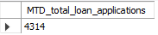

PMTD Loan Applications :
SELECT
COUNT(id) AS PMTD_total_loan_applications
FROM
bank_loan_data
WHERE
MONTH(issue_date) = 11
AND YEAR(issue_date) = 2021
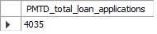

Total Funded Amount :
SELECT
SUM(loan_amount) AS total_funded_amount
FROM
bank_loan_data
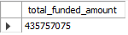

MTD Total Funded Amount :
SELECT
SUM(loan_amount) AS MTD_total_funded_amount
FROM
bank_loan_data
WHERE
MONTH(issue_date) = 12
AND YEAR(issue_date) = 2021
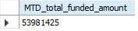

PMTD Total Funded Amount :
SELECT
SUM(loan_amount) AS PMTD_total_funded_amount
FROM
bank_loan_data
WHERE
MONTH(issue_date) = 11
AND YEAR(issue_date) = 2021
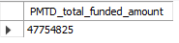

Total Amount Received :
SELECT
SUM(total_payment) AS total_amount_recived
FROM
bank_loan_data
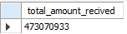

MTD Total Amount Received :
SELECT
SUM(total_payment) AS MTD_total_amount_recived
FROM
bank_loan_data
WHERE
MONTH(issue_date) = 12
AND YEAR(issue_date) = 2021
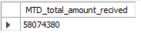

PMTD Total Amount Received :
SELECT
SUM(total_payment) AS PMTD_total_amount_recived
FROM
bank_loan_data
WHERE
MONTH(issue_date) = 11
AND YEAR(issue_date) = 2021
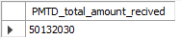

Average Interest Rate :
SELECT
ROUND(AVG(int_rate) * 100, 2) AS avg_interest_rate
FROM
bank_loan_data
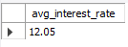

MTD Avg Interest Rate :
SELECT
ROUND(AVG(int_rate) * 100, 2) AS MTD_avg_interest_rate
FROM
bank_loan_data
WHERE
MONTH(issue_date) = 12
AND YEAR(issue_date) = 2021
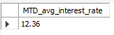

PMTD Avg Interest Rate :
SELECT
ROUND(AVG(int_rate) * 100, 2) AS PMTD_avg_interest_rate
FROM
bank_loan_data
WHERE
MONTH(issue_date) = 11
AND YEAR(issue_date) = 2021
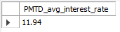

Avg Debt To Income Ratio :
SELECT
ROUND(AVG(dti) * 100, 2) AS avg_dti
FROM
bank_loan_data
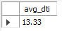

MTD Avg Debt To Income Ratio :
SELECT
ROUND(AVG(dti) * 100, 2) AS MTD_avg_dti
FROM
bank_loan_data
WHERE
MONTH(issue_date) = 12
AND YEAR(issue_date) = 2021
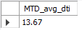

PMTD Avg Debt To Income Ratio :
SELECT
ROUND(AVG(dti) * 100, 2) AS PMTD_avg_dti
FROM
bank_loan_data
WHERE
MONTH(issue_date) = 11
AND YEAR(issue_date) = 2021
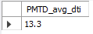

GOOD LOAN ISSUED
Good Loan Percentage :
SELECT
ROUND((COUNT(CASE
WHEN
loan_status = 'Fully Paid'
OR loan_status = 'Current'
THEN
id
END) * 100) / COUNT(id),
2) AS good_loan_percentage
FROM
bank_loan_data
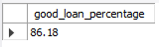

Good Loan Applications :
SELECT
COUNT(id) as good_loan_applications
FROM
bank_loan_data
WHERE
loan_status = 'Fully Paid'
OR loan_status = 'Current'
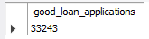

Good Loan Funded Amount :
SELECT
sum(loan_amount) as good_loan_funded_amount
FROM
bank_loan_data
WHERE
loan_status = 'Fully Paid'
OR loan_status = 'Current'
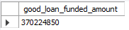

Good Loan Received Amount :
SELECT
sum(total_payment) as good_loan_received_amount
FROM
bank_loan_data
WHERE
loan_status = 'Fully Paid'
OR loan_status = 'Current'
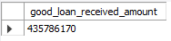

BAD LOAN ISSUED
Bad Loan Percentage :
SELECT
ROUND(COUNT(CASE
WHEN loan_status = 'Charged off' THEN id
END) * 100 / COUNT(id),
2) AS bad_loan_percentage
FROM
bank_loan_data
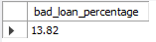

Bad Loan Applications :
SELECT
COUNT(id) AS bad_loan_applications
FROM
bank_loan_data
WHERE
loan_status = 'Charged off'
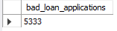

Bad Loan Funded Amount :
SELECT
sum(loan_amount) AS bad_loan_funded_amount
FROM
bank_loan_data
WHERE
loan_status = 'Charged off'
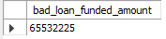

Bad Loan Received Amount :
SELECT
sum(total_payment) AS bad_loan_received_amount
FROM
bank_loan_data
WHERE
loan_status = 'Charged off'
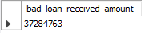

Loan Status :
SELECT
loan_status,
COUNT(id) AS total_loan_applications,
SUM(total_payment) AS total_amount_received,
SUM(loan_amount) AS total_funded_amount,
AVG(int_rate * 100) AS interest_rate,
AVG(dti * 100) AS dti
FROM
bank_loan_data
GROUP BY loan_status
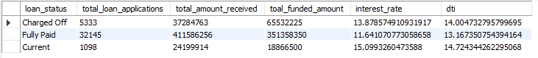

MTD Total Funded And MTD Total Received Amount Loan Status :
SELECT
loan_status,
SUM(total_payment) AS MTD_total_amount_received,
SUM(loan_amount) AS MTD_total_funded_amount
FROM
bank_loan_data
WHERE
MONTH(issue_date) = 12
GROUP BY loan_status
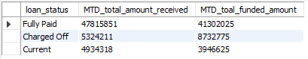

BANK LOAN REPORT | OVERVIEW
Month :
SELECT
MONTH(issue_date) AS month_number,
DATE_FORMAT(issue_date, '%M') AS month_name,
COUNT(id) AS total_loan_applications,
SUM(total_payment) AS total_amount_received,
SUM(loan_amount) AS total_funded_amount
FROM
bank_loan_data
GROUP BY MONTH(issue_date) , DATE_FORMAT(issue_date, '%M')
ORDER BY MONTH(issue_date)
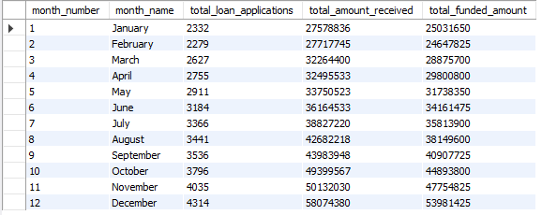

State :
SELECT
address_state AS state,
COUNT(id) AS total_loan_applications,
SUM(total_payment) AS total_amount_received,
SUM(loan_amount) AS total_funded_amount
FROM
bank_loan_data
GROUP BY address_state
ORDER BY address_state
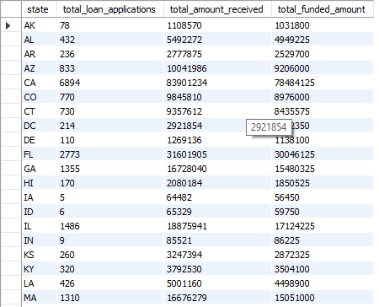

Term :
SELECT
term,
COUNT(id) AS total_loan_applications,
SUM(total_payment) AS total_amount_received,
SUM(loan_amount) AS total_funded_amount
FROM
bank_loan_data
GROUP BY term
ORDER BY term
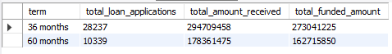

Employee Length :
SELECT
emp_length as employee_length,
COUNT(id) AS total_loan_applications,
SUM(total_payment) AS total_amount_received,
SUM(loan_amount) AS total_funded_amount
FROM
bank_loan_data
GROUP BY emp_length
ORDER BY emp_length
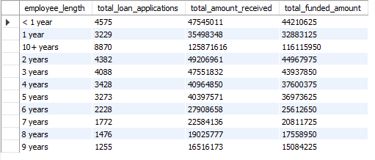

Purpose :
SELECT
purpose,
COUNT(id) AS total_loan_applications,
SUM(total_payment) AS total_amount_received,
SUM(loan_amount) AS total_funded_amount
FROM
bank_loan_data
GROUP BY purpose
ORDER BY COUNT(id) DESC
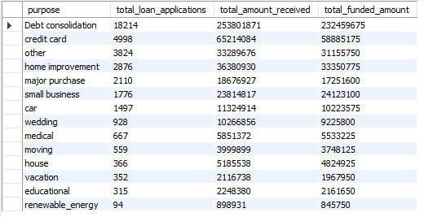

Home Ownership :
SELECT
home_ownership,
COUNT(id) AS total_loan_applications,
SUM(total_payment) AS total_amount_received,
SUM(loan_amount) AS total_funded_amount
FROM
bank_loan_data
GROUP BY home_ownership
ORDER BY COUNT(id) DESC
